**DAILY ONLINE ACTIVITIES SUMMARY**

|  |  |  |  |  |  |  |  |  |
| --- | --- | --- | --- | --- | --- | --- | --- | --- |
| **Date:** | **03/07/2020** | | | | | **Name:** | **Shailashree** | |
| **Sem & Sec** | **IV sem & B section** | | | | | **USN:** | **4AL18CS077** | |
| **Online Test Summary** | | | | | | | | |
| **Subject** | | **-** | | | | | | |
| **Max. Marks** | | **30** | | **Score** | | | **-** | |
| **Certification Course Summary** | | | | | | | | |
| **Course** | **Predictive modeling and analysis** | | | | | | | |
| **Certificate Provider** | | | **Greatlearning academy** | | **Duration** | | | **2.5hours** |
| **Coding Challenges** | | | | | | | | |
| **Problem Statement1:** -------------------------------------------------------- | | | | | | | | |
| **Status: No Executed** | | | | | | | | |
| **Uploaded the report in Github** | | | | | **N0** | | | |
| **If yes Repository name** | | | | | **----** | | | |
| **Uploaded the report in slack** | | | | | **YES** | | | |

Online Test Summary: No internals conducted today.

Online Certification Course Summary: Today I started new course that Predictive modeling and analysis in Great Learning. In today’s session I have learnt about introduction of predictive modeling.

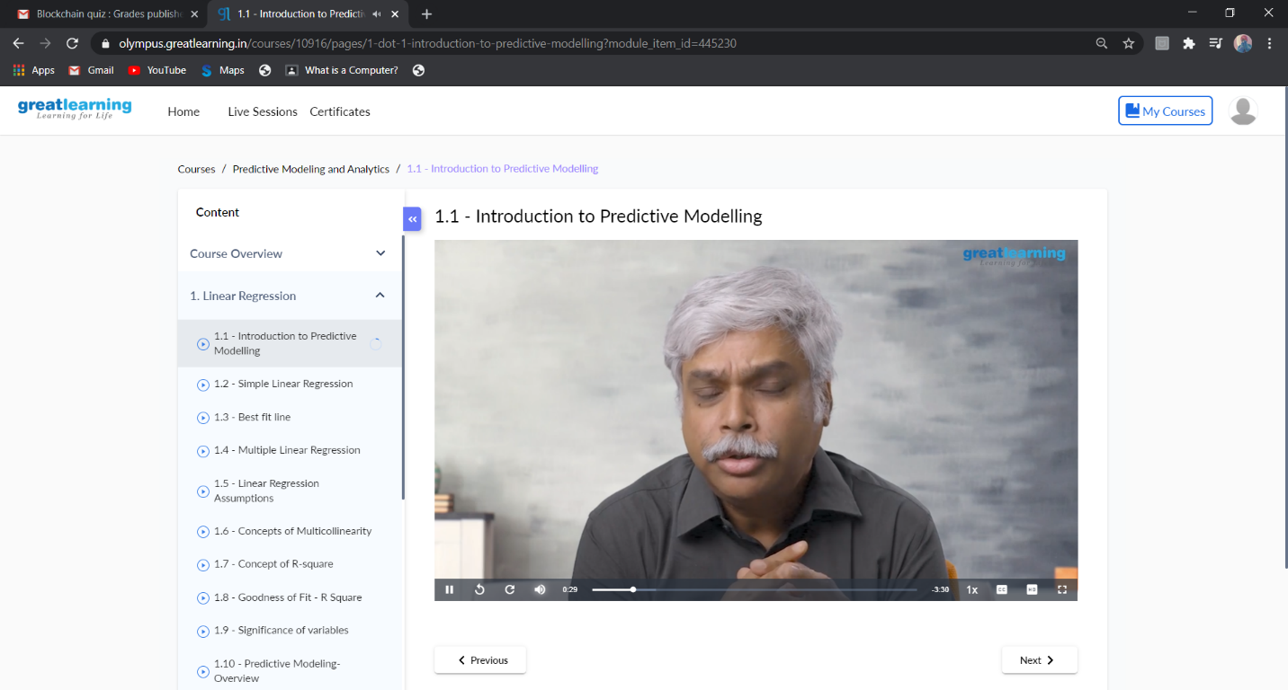

These are the snap shots of today’s sessions.

Online Coding Summary: No programs were given today.

Online Training: Today I had attended the online training organized by CSE Department AIET. The training was on C programming language done by Prof. Megha Hegde. CSE Dept. After the session the quiz was conducted.

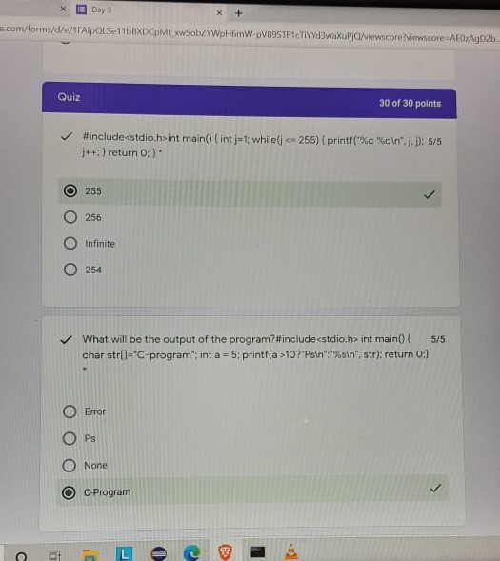

**This is the Snapshot of the quiz attempted and scores obtained.**